1. Sparse Matrix
Aim:
Sparse Matrix implementation using circular linked list

Theory:

I. Sparse Matrix
A matrix is a two-dimensional data structure that has a total of m*n values, where
- m is the number of rows, and
- n is the number of columns
A dense matrix is a matrix in which most of the elements have a non-zero value. As opposed to a dense matrix, a matrix that has many or most elements with a zero value, is called a sparse matrix. There are varying data storage and analysis techniques related to the use of sparse matrices. The sparsity of a matrix is defined as the number of zero valued elements divided by the total number of elements.

II. Linked Representation of Sparse Matrix
The linked representation of a sparse matrix represents each column of the sparse matrix in a circular linked list with a header node. Moreover, each row of the sparse matrix is also represented as a circular linked list with a header node. Other than the header nodes, each node in the linked list, represents a non-zero value in the matrix. Each such node is made up of 5 fields:
- VALUE: contains the non-zero data item
- RIGHT: used to link to the next non-zero element in the same row
- DOWN: used to link to the next non-zero element in the same column
- ROW: used to denote the row to which, this non-zero element belongs
- COL: used to denote the column to which, this non-zero element belongs
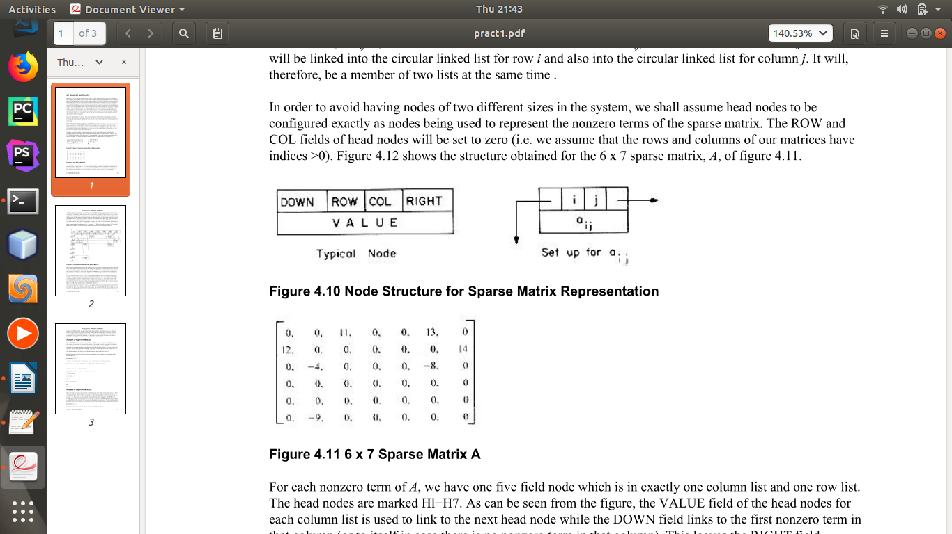

Fig 1. Structure of the Node

III. Advantages of using Linked Representation of Sparse Matrices
The major advantages of using the linked representation of sparse matrices are as listed below:
- Storage – Instead of storing zero values, along with non-zero values, linked representation can be used to store only non-zero elements to make effecient use of storage space.
- Traversal Time – Traversing a sparse matrix which stores only the non-zero elements, is faster.
- Computing Time – A lot of computing time can be saved using the linked representation of sparse matrices, where only non-zero elements are traversed.

Implementation:
#include<stdio.h>
#include<stdlib.h>

struct Node{
int row,col,val1;
struct Node *right,*down,*val2;
};

void printList(struct Node *first);
void printList2(struct Node *first);
void main(){
int m,n,i,j,k,head_nodes,prev,x,p,q,r,count;
count=0;
printf("Enter number of rows and columns:");
scanf("%d%d",&m,&n);

if (m>=n){
head_nodes=m;
}
else {
head_nodes=n;
}
//Step 1: Create Dimension Node
struct Node* main;
main = (struct Node*)malloc(sizeof(struct Node));

//Array of header nodes
//Step 1: Create
struct Node* head[head_nodes];
//Step 2: Init
for (i=0;i<head_nodes;i++) {
head[i] = (struct Node*)malloc(sizeof(struct Node));
head[i]->row=i+1;
head[i]->col=i+1;
head[i]->right=head[i];
head[i]->down=head[i];
head[i]->val1=0;
}
//Step 2: Init Dimension Nodes
main->row=m;
main->col=n;
main->val2=head[0];
//Set header nodes to point to next header node
for (i=0;i<head_nodes-1;i++) {
head[i]->val2=head[i+1];
}
//Set last header node to point to the dimension node
head[i]->val2=main;

printf("Enter number of non zero elements:");
scanf("%d",&x);
//Step 1: Create array of data nodes that store the non-zero elements
struct Node* elements[x];
//Step 2: Init element nodes with the row, col index and data
for (i=0;i<x;i++) {
printf("Enter row column and val for Node%d",i+1);
scanf("%d%d%d",&p,&q,&r);
if(p > m || q > n) {
printf("\nEnter a valid row-column pair");
i--;
continue;
}
elements[i]=(struct Node*)malloc(sizeof(struct Node));
elements[i]->row=p;
elements[i]->col=q;
elements[i]->val1=r;
}

for (i=0;i<m;i++) {
//Traversing the array of header nodes row-wise
count=0;
prev=0;
for (j=0;j<x;j++) {
if (elements[j]->row == (i+1) && count==0) {
count+=1;
head[i]->right=elements[j];
elements[j]->right=head[i];
prev=j;
}
else if (elements[j]->row == (i+1) && count>0) {
count+=1;
elements[prev]->right=elements[j];
elements[j]->right=head[i];
prev=j;
}
}
}
for (i=0;i<n;i++) {
//Traversing the array of header nodes row-wise
count=0;
prev=0;
for (j=0;j<x;j++) {
if (elements[j]->col == (i+1) && count==0) {
count+=1;
head[i]->down=elements[j];
elements[j]->down=head[i];
prev=j;
}
else if (elements[j]->col == (i+1) && count>0) {
count+=1;
elements[prev]->down=elements[j];
elements[j]->down=head[i];
prev=j;
}
}
}

printf("\n\n ** Row wise Traversal ** \n");
for (i=0;i<head_nodes;i++) {
printf("\n");
printList(head[i]);
}
printf("\n\n ** Column wise Traversal ** \n");
for (i=0;i<head_nodes;i++) {
printf("\n");
printList2(head[i]);
}
printf("\n");
}
/* Function to traverse a given Circular linked list and print nodes */
void printList(struct Node *first) {
struct Node *temp = first;
// If linked list is not empty
if (first != NULL) {
// Keep printing nodes till we reach the first node again
do{
printf(" %d %d %d -->", temp->row,temp->col,temp->val1);
temp = temp->right;
}while (temp != first);
}
}

void printList2(struct Node *first) {
struct Node *temp = first;
// If linked list is not empty
if (first != NULL) {
// Keep printing nodes till we reach the first node again
do{
printf(" %d %d %d -->", temp->row,temp->col,temp->val1);
temp = temp->down;
}while (temp != first);
}
}

Screenshots:
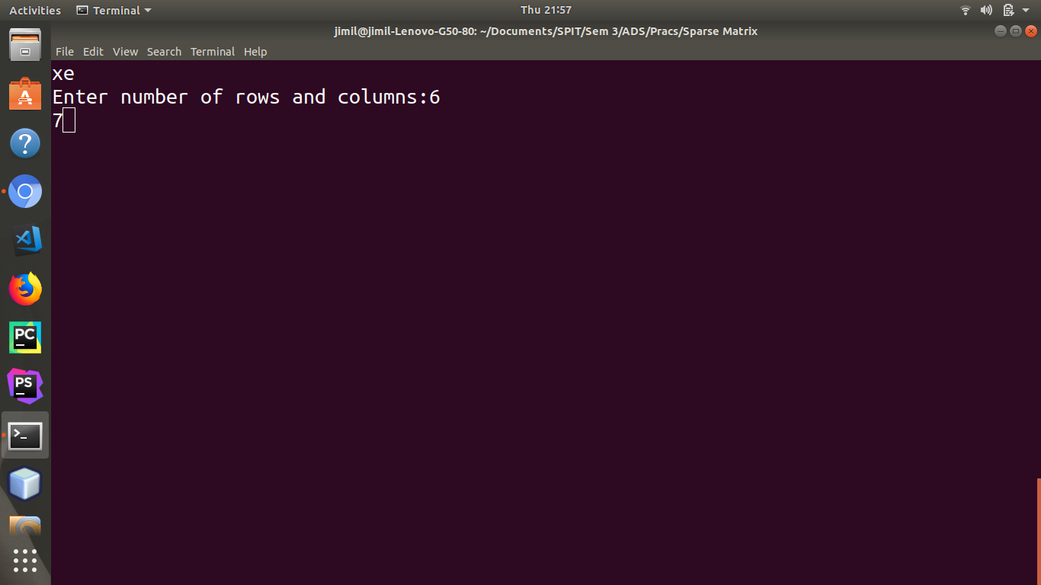
Fig 2.1. Step 1 – Enter the number of rows and columns
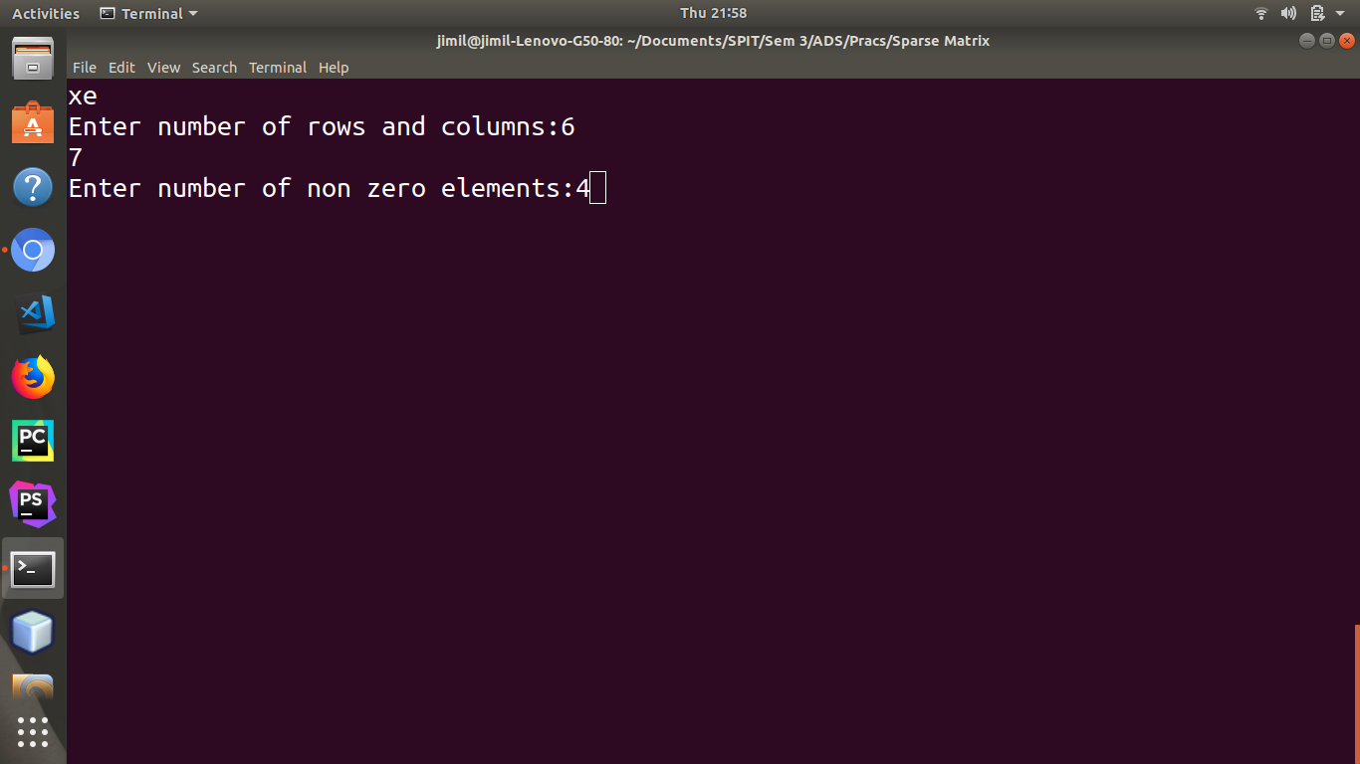
Fig 2.2. Step 2 – Enter the number of non-zero elements
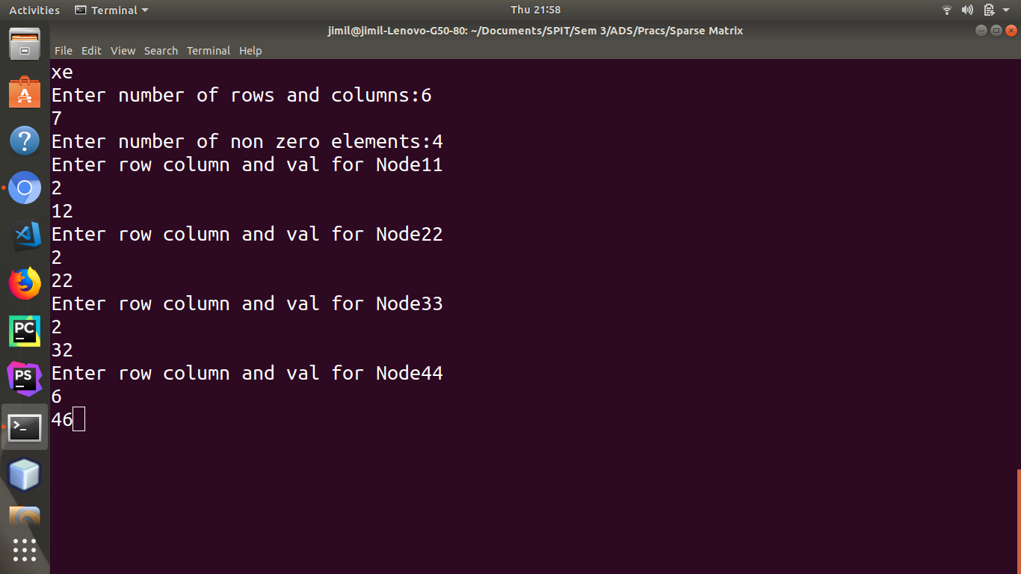
Fig 2.3. Step 3 – Enter the ROW, COL, and VAL values for each non-zero data node
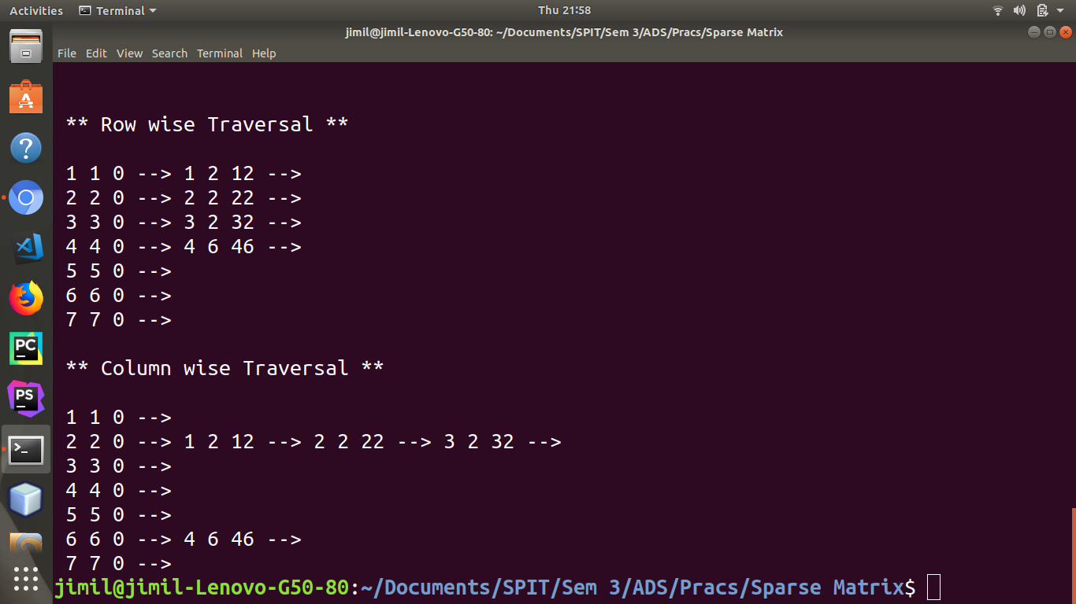
Fig 2.4. Step 4 – Linked Representation of Sparse Matrix

Results:
Computing large-scale applications such as solving partial differential equations using the finite element method requires the use of Sparse Matrices. Sparse Matrices are also used in various other data analysis and machine learning applications, including Natural Language Processing (NLP). Linked representation of Sparse Matrices is quite fruitful over array representation, since storage space and computing time are minimized.

Conclusion:
Thus, from this experiment, we have realized the concept of sparse matrices using a linked representation.

